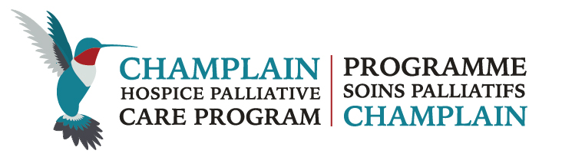

Annual Report
Collaboration, Quality and Knowledge
REport to March 31, 2016
Prepared in the summer 2016
Members of the Board of Directors, Staff and Committee Chairs

EXECUTIVE  Kim Peterson, Chair  Onno Kremers, Vice-Chair  Sheryl Cross, Treasurer  Sylvie Lefebvre, Past-Chair  DIRECTORS  Joanne Bezzubetz  Maryse Bouvette  Diane Caughey  Lloyd Cowin  Lynn Kachuik  Janet Morris  Jean-François Pagé  Lisa Sullivan  Nigel Van Loan  Catherine Van Vliet  Peggy Dick | NON-VOTING MEMBERS  Cathy DeGrasse, Regional Cancer Program  Elan Graves, Local Health Integration Network (LHIN)  Anne Mantha – Host Agency, Bruyère Continuing Care  Glenda Owens - Host Agency, Community Care Access Centre (CCAC)  Dr. Jill Rice, Regional Palliative Clinical Lead  PROGRAM STAFF  Cathy Simpson, Decision Support Coordinator  Cheryl Teeter, Program Development Officer  Hermelle Thivierge, Program Assistant  Nadine Valk, Executive Director
Clinical Advisory Group: Dr. Jill Rice

Education and Information Specialty Committee: Diane Roscoe and Debbie Watt, Co-Chairs

Standards, Indicators and Quality Specialty Committee: Dr. Christopher Klinger, Chair

Bereavement Leadership Team: Pam Grassau, Chair

Eastern Counties Network: Jason Samson, Chair

Ottawa Network: Sheryl Cross, Chair (until October 2015)/Debbie Watt, Chair

North Lanark Network: Christine Bois, Chair

Renfrew Network: Dylaina Wood, Chair

Our Message
This fifth year of existence for the Champlain Hospice Palliative Care Program (CHPCP) has been filled with exciting accomplishments and it is with great pride that we provide this annual report to the communities of the Champlain Region. As a result of the Ministry of Health’s commitment to improving care at the end of life, it has established a new provincial infrastructure, the Ontario Palliative Care Network (OPN), with clear accountability to drive the delivery of quality hospice palliative care services across the province. Because of the dedication and foresight of Champlain Local Health Integration Network (CLHIN), our region has already embarked on this journey. For the past five years, we have had a Board whose membership, roles, responsibilities and skills already align with the recommended structure proposed for all palliative programs/networks across Ontario. The provincial priority for improving the caregiver’s experience is also an ongoing priority locally.

The successful establishment of the Champlain Hospice Palliative Care Program is the result of significant contributions from numerous providers and professionals who participated in the planning and development of the program objectives. This emphasis on partnership will continue as we plan for the increased investment in hospice care that has been promised by the Ministry of Health and Long Term Care.

All of the accomplishments of our program result from the time and commitment of individuals, communities and partners across this vast region. The CHPCP continues to engage key stakeholders as we continue to move forward on our action plan commitments: providing equitable access to care, care across the continuum, and capacity-building, with a particular focus on developing palliative care in our rural communities.


The Champlain region has been recognized as a leader in the provision of hospice palliative care services. It is the dedication of numerous individuals, professionals and organizations that make this possible. Thank you to everyone for working together to ensure that people receive the best possible care at the end of their lives.


Kim Peterson, Chair Nadine Valk, Executive Director
Tel 613-683-3779 Tel 613-683-3779
nvalk@champlainpalliative.ca
Champlain Hospice Palliative Care Program
69 Primrose Avenue, Annex C, Saint-Vincent Hospital
Ottawa ON K1R 6M1 Tel 613-683-3779 www.champlainpalliative.ca
Please direct any questions and suggestions for improvement on our approach to this reporting to the contacts listed above.

To Our Members and the Community at Large

STRATEGIC PLAN AND PRIORITIES
The mission of the CHPCP is to lead the development and support of a person and family-centered, integrated, hospice palliative care system in Champlain.
Funded by the Champlain Local Health Integration Network (LHIN), the regional program works to bring together a wide range of expertise to help coordinate care, assist with planning, develop performance measures and collaborate with health service providers to improve the quality of life for individuals and their loved ones at end-of-life.
The Champlain LHIN has approved the CHPCP regional action plan for 2014-2019. The plan was developed in consultation with multiple stakeholders, community and health system partners. Recommendations are organized into three focus areas:
  - Focus Area 1: Equitable access to hospice palliative care
  - Focus Area 2: Hospice palliative care across a full continuum of care
  - Focus Area 3: Building capacity across care settings

This strategic plan guides our operational planning and priorities year-to-year.

Focus Area 1: Equitable access to hospice palliative care

Engaging primary care providers and building capacity at the primary level
CHPCP has been helping to facilitate training and education events across the region and has worked with the LHIN Primary Care Lead and the Bruyère Research Institute to support work to create a primary care physician inventory. The first phase of this project with Family Health Teams across the region has been completed and we will work with the LHIN to develop a more comprehensive inventory in 2016.
Work will continue in 2016 to plan coordinated outreach efforts with partner organizations such as the Regional Palliative Consultation Team, the Community Care Access Centre and Hospice Care Ottawa. As well to plan and promote tools and resources which will support primary care providers: the Central Referral and Triage System, promoting and expanding EDITH (the expected death in the home protocol), the Pain and Symptom Management Kits, and the CHPCP website.

Focus Area 2: Hospice palliative care across a full continuum of care
Enhance and support hospice palliative care community programs and services
Research shows that people would like to die at home but that the majority of people do not die in their preferred place of choice. For this reason, “enhancing in-home palliative services” (Focus Area 2: 1.) is identified as a high-priority within the 2014-2015 Action Plan. Our work in this area has centered on the “Hospice Care in the Community” pilot project. The LHIN pilot project funding received by CHPCP offers a tremendous opportunity for the region to engage in action research to develop models of hospice level care in the community: enhancing access, providing and supporting quality end of life care for people at home, assisted living and community hospitals.
The one-time funding for this project has allowed CHPCP to develop a proof of concept project plan with the Algonquins of Pikwàkanagàn First Nation and with Assisted Living Services for High Risk Seniors (ALS-HRS). The funding will be used to extend HPC care around the individual and their families/increase hours of support as well as enhance care coordination across service providers.
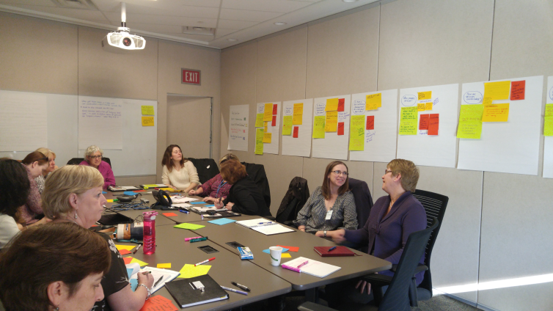
Journey mapping exercises were completed with both Pikwàkanagàn First Nation and ALS-HRS: a process flowchart that illustrates a typical client’s progression through the health system from being referral to case conferencing to bereavement support. The map illustrates the “current state” interaction with services and providers and the desired “future state” for the community. This information was used to plan service enhancements and address challenges within current processes.

Focus Area 3: Capacity building across care settings
Facilitate bereavement support and advance care planning.
Advance Care Planning
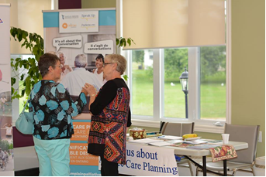
An Advance Care Planning (ACP) Leadership Team was formed to provide support for public education, regional work on “Goals of Care” documentation and health care provider education. We recruited and trained a number of volunteer community facilitators across the region to deliver ACP public education sessions.
The CHPCP will help coordinate presentations around the region, provide materials and ongoing training. We worked in partnership with Pallium Canada and the Ottawa Hospital to update the videos used in the “Essential Conversations” training module to extend the content to all healthcare providers (it was primarily physician focused).
CHPCP invited representatives from hospitals, long-term care homes and primary care to participate in an information session on “goals of care” documentation in health care facilities. There is agreement that we need to support shared definitions and understanding in the region for these types of documents and how they are used so that they are reflective of the Health Care Consent Act in Ontario. Work will continue on this initiative in 2016-2017.

Bereavement
A Bereavement Leadership Team was formed to guide implementation of the regional bereavement plan with a focus in 2015-2016 on developing a regional bereavement inventory, grief and bereavement resources and training for volunteers.
CHPCP developed a training package to support enhanced grief and bereavement training to be provided to volunteers around the region. The training package includes a facilitator’s guide and participant’s workbook and includes modules on grief and bereavement, the art and skill of sensitive communication, supporting (companioning) individuals, group facilitation and self-care. We held a train-the-trainer session at the end of March for volunteer coordinators across the region as well as members of the Bereavement Leadership Team.
CHPCP has also developed grief and bereavement resources for use in the region. These will also be available on the CHPCP website once it has been redeveloped (late fall of 2016).

Operating Highlights
Much of 2015-2016 was spent refining process, structure, and relationships to support implementation of the regional action plan and enhance communications. In February 2015, the Champlain Hospice Palliative Care Program (CHPCP) created the first of its regular e-Newsletters. Over the past year, we have increased our distribution list by about 33% to over 200 people. Our open rate average is 42%, almost 10% higher than the industry average.
A governance review was completed by the Governance Committee to assess structure as well as committee mandates. We were able to recruit a summer student through Sprott MBA program to support the work of the Governance Committee to develop new Committee and Board Charters.
There is a very active and committed competency based Board responsible for stewardship of the CHPCP as well as a number of Committees and Networks, each with a work plan which is directly linked to implementation of the Regional Action Plan. There are over 50 organizations involved in our work, representing hospitals, hospices, long-term care and other members of our community including caregivers, counsellors, First Nations and Francophones.
We were very fortunate to have Dr. Jill Rice join the program as the regional palliative care lead. In her role, Dr. Rice works among provincial, regional and local health care providers, the LHIN and Regional Cancer Program to help plan, develop, and coordinate end-of-life and hospice palliative care services across the Champlain region.
Decision Support/Standards, Indicators, Quality Committee
In 2015 we were also able to hire a .5 Decision Support Coordinator (DSC), Cathy Simpson, who is already having a tremendous impact in moving our work forward. Cathy has been conducting Data Capacity Reporting Assessments and creating Reporting Requirements Tools (e.g. a tool to collect volunteer hours) with and for hospices across the region. This work identified the need for a data quality refresher training session which will take place in March with the Ministry of Health Data Branch and includes hospices and LHIN representatives from Champlain as well as some partners from the South East LHIN.
The DSC has been trained by the Ministry and is approved to access IntelliHEALTH which includes data from hospital services, community care, medical services, vital statistics and population data. Reports created from this data are used to inform operational planning and decision making processes and are being used to establish a set of indicators that will flow out from CHPCP to our stakeholders on a quarterly basis.
In fiscal year 2014-15, 6 organizations within the Community and Support Services Sector, offering either Visiting Hospice Services OR Palliative Care Education reported a total of 177,630 hours of Volunteer service.
That’s equivalent to 91 full time equivalent staff.


Program Development/Education
Much of the Program Development Officer’s (PDO) role involves planning and promoting education for health care providers, the community and other stakeholders, as well as supporting the work of the Education and Information Specialty Committee.

The Education and Information Specialty Committee uses the Education Framework and strategy approved by the Board to develop its yearly work plan. Sub committees met to work on specific tasks like establishing criteria for approving 3 Community College training programs for PSWs. One significant project started in November was to review and revise the Pallium “Difficult Discussions” videos used in LEAP training. This work will continue until March 2016.

The primary annual education event is planning and delivering a HPC Education day in both English and French. The French Palliative education days was held at the Chimo Inn on April 16th with about 80 in attendance. The English HPC Day was held on May 13th with guest speaker Dr. Christina Puchalski. About 180 people attended.

Other activities included a satellite ½ day session before the CHPCA conference for a LTC audience, a volunteer coordinator retreat with Mr. Geraldo Quintanar as guest speaker, as well as a number of presentations with and for community organizations and partners including:
- In partnership with Bruyère Continuing Care and The Ottawa Hospital, Dr. Ed Fitzgibbon gave a presentation on Advance Care Planning Day on April 16th.
- An evening session for the public was held on May 12th with Dr. Puchalski speaking on Spirituality at the End of Life: A time to listen and Care.
- On World HPC Day, November 26th Wendy Muckle gave an interesting and informative presentation on 'Achieving Universal Coverage of Palliative Care: Hidden Lives – Hidden Patients’.

In September the CHPCP entered into a service agreement with Bruyère Continuing Care for the PDO to assist with planning education initiatives funded by the LHIN including an evening “Dine to Learn” series with sessions on “Staff Grieve Too” and “Your Work Matters” for a LTC audience as well as LEAP sessions in Renfrew, Winchester, Arnprior, Cornwall, Ottawa and Petawawa.

REGIONAL HIGHLIGHTS - Champlain’s Hospice Palliative Care Services

BETH DONOVAN HOSPICE
In February 2016, the Board and Staff of Beth Donovan Hospice announced the purchase of their “forever home” on French Settlement Road. This 3100 square foot building is situated on 5 acres of land and will house current and future programs once renovations are completed. The purchase of this home was made possible by generous donors who contributed to the Beth Donovan building fund over the past 20 years as well as a bequest from Audrey McClenaghan, a long-time friend of the hospice.

EASTERN COUNTIES DAY HOSPICE DEVELOPMENT
New day hospice programs were opened in 2015-2016 at Dundas County Hospice, Hospice Cornwall and at a site in Hawkesbury. Day Hospice offers a day away where clients will find rest and relaxation, supportive relationships, and therapeutic value. Day Hospice may host various activities each week, for example, arts and crafts, massage and reflexology therapies, music, card games, and spa days.

HOSPICE CARE OTTAWA
The past year has been a successful one. Highlights include:
- Opening our doors to La Maison de l’Est in Orléans thereby offering our community programs in French
- Securing a loan and raising sufficient funds to begin construction of 10 in-patient hospice rooms and two palliative care respite rooms in ‘Hein House’, the residential wing of Ruddy-Shenkman Hospice
- Refreshing the May Court Hospice site interior to make the building an even more home-like environment for patients and families

HUB HOSPICE
June 2015 to June 2016 saw substantial growth for Hub Hospice Palliative Care (HHPC) with more clients, more volunteers, greater recognition in the communities they serve and more linkages with health and social colleagues in their area. The Friends of Hospice group has also grown during the year and supported numerous events.

Hub hospice has revised their mission and vision and developed a three-year strategic plan which guides their work. Their Vision recognizes the importance of and need for a greater understanding of advance care planning, death and dying throughout the community. A number of community events have been held to support this vision.

ROGER NEILSON HOUSE
As one of only six pediatric palliative care hospices in Canada, Roger Neilson House is staffed by doctors, nurses, social workers, therapists and support staff, and relies on volunteers, all of whom assist children and youth who are medically fragile and are at significant risk of dying before adulthood. More than 3,000 children and youth from Ontario, western Quebec and Nunavut have been admitted to Roger Neilson House since it opened. In 2015-2016, Roger Neilson House added a range of new services and expanded programs to those we already provided. These include enhanced bereavement support, “SIBS” - Spectacular Incredible Brave Siblings - which offers emotional support for the brothers and sisters of those in palliative care, and a Home Hospice Program which sends volunteers to a family’s home for a few hours a week to help the parents, and give them a break at home.

MADAWASKA VALLEY HOSPICE
In the spring of 2015, Madawaska Valley Hospice (MVH) accepted their first admission to its’ 2 bed, 1400 square foot “Home away from Home” hospice suite within St. Francis Hospital in Barry’s Bay and the hospice delivered care to 39% of families that experienced a death in their catchment communities. This new rural model of hospice palliative care received the Renfrew County Warden’s Service Award for the impact this program is making in the community. The model was presented at the Hospice Palliative Care Ontario (HPCO) Ontario Conference and Lisa Hubers, Program Director, was invited to join the HPCO Rural Community of Practice because of the success of this model of care in rural Ontario.

